Fast ForWord Instructions
- www.scilearn.com
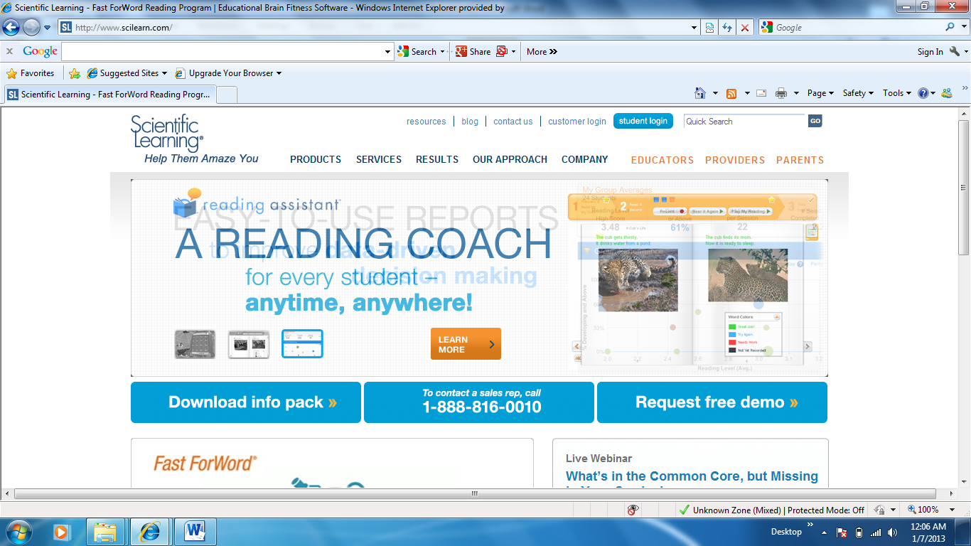
- Student Log In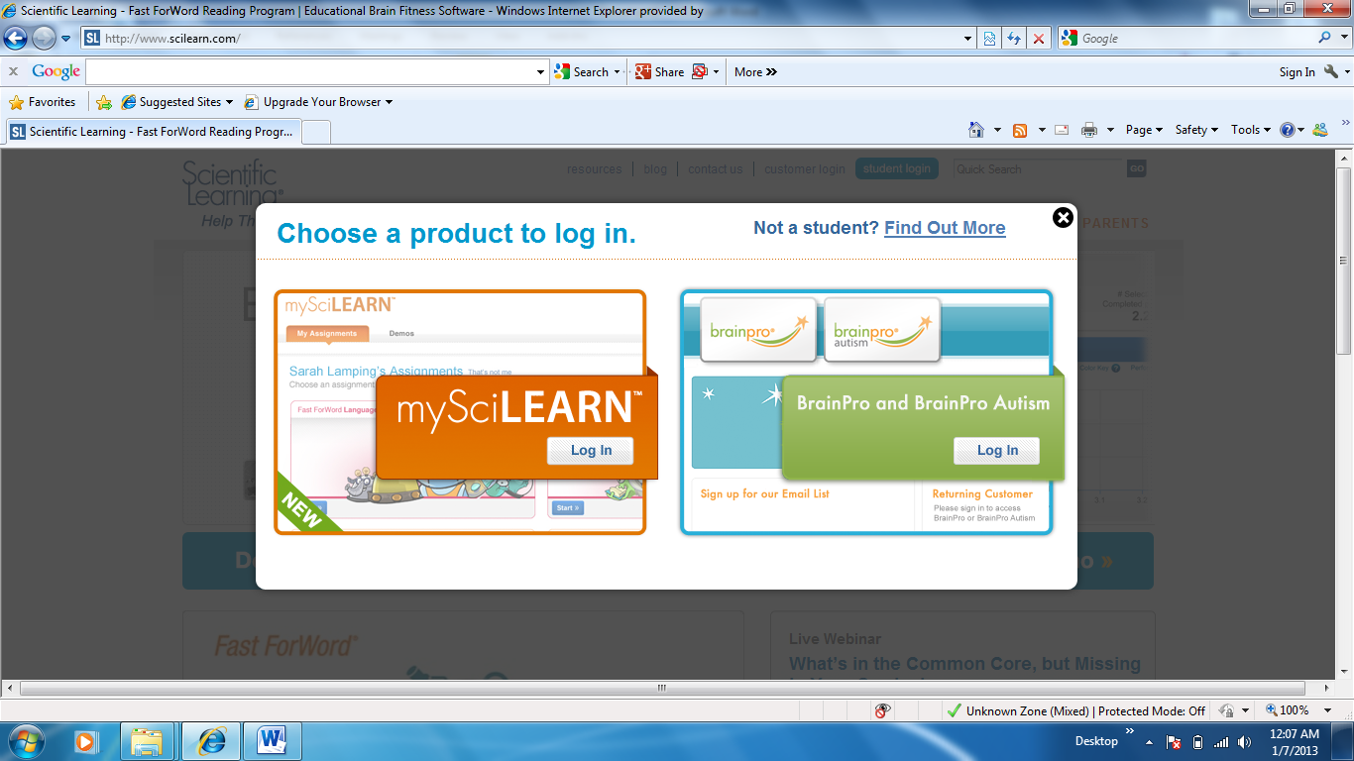

- Type/Select “Cumberland County School District”
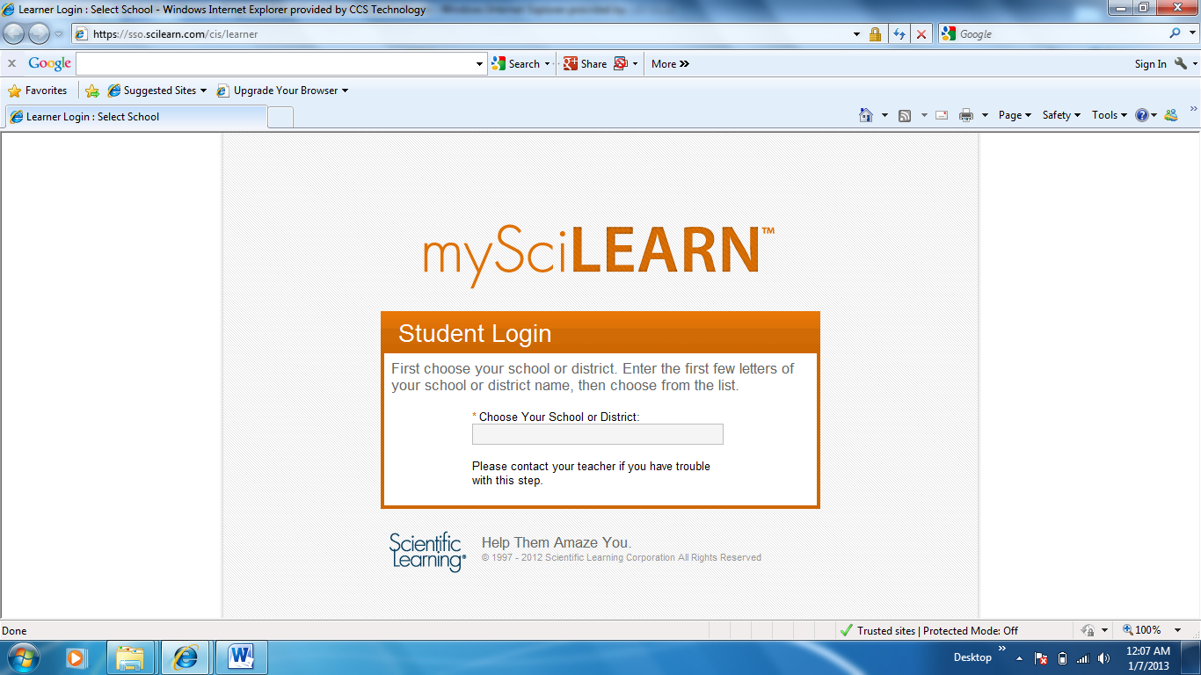
- Then select continue

- Type your “username” then select “continue”
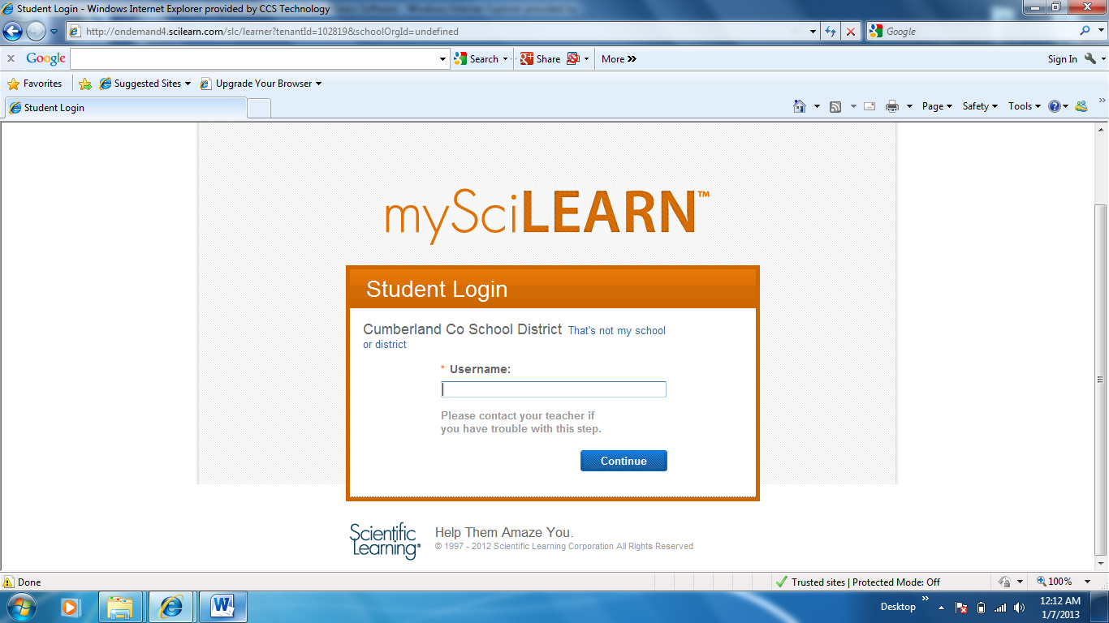

USERNAME______________________________

- Type your password
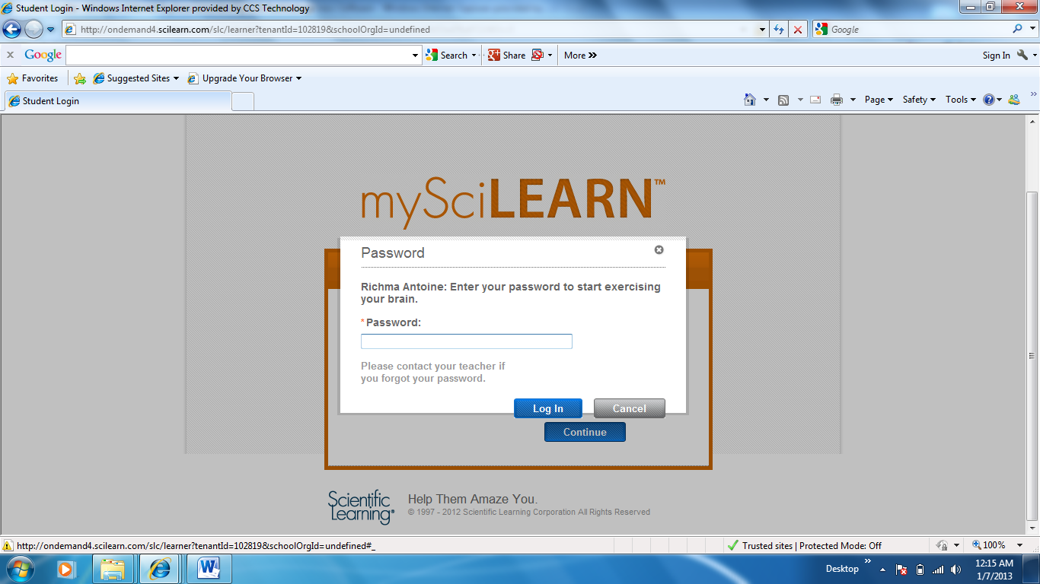
J

PASSWORD___________________________
- Begin your assignment by selecting “start”
NOTE: YOUR ASSIGNMENT PAGE MAY NOT LOOK LIKE THE PICTURE BELOW.
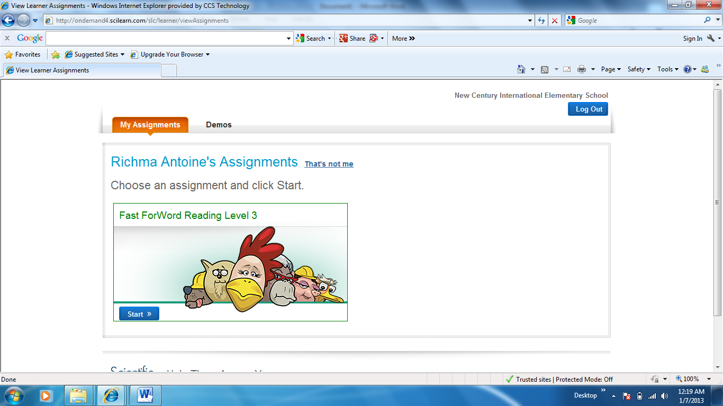
John Doe’s
- Select a highlighted assignment

- Complete ALL tasks highlighted and record your score on your Completion and Points charts.
HAVE FUN!!!

